TUTORIAL – 9: BLACK-BOX & WHITE-BOX TESTING
Website: OrangeHRM Demo | Login Module

Aim
To apply Black-Box Testing, White-Box Testing, Integration Testing, and System Testing to the Login Module of the Student Management System, using the OrangeHRM Demo website for observable login and dashboard behavior where applicable.

Description
Black-Box Testing checks application behavior using inputs and outputs without examining internal code. White-Box Testing checks internal statements, conditions, and branches and therefore requires source code access. Integration Testing verifies communication between modules. System Testing checks the behavior of the complete application.

Problem Statement
Perform Black-Box, White-Box, Integration, and System Testing for login-related behavior. Record test inputs, expected results, actual results, status, and screenshot evidence. OrangeHRM Demo is used as the live web application for login and dashboard observations; its internal source code is not available to the tester, so White-Box testing is demonstrated separately with a small sample Python login program.

Website and Test Environment
Parameter | Details
Project Name | Student Management System / Login Module
Website Used | OrangeHRM Open-Source Demo
Demo URL | https://opensource-demo.orangehrmlive.com/web/index.php/auth/login
Application Type | Web application
Browser | Google Chrome
Testing Techniques | Black-Box, White-Box, Integration, System
Demo Login | Username: Admin | Password: admin123

Requirements Under Test
R001: User should be able to log in with valid credentials.
R002: Invalid credentials should display an error message and should not open the dashboard.
R003: Blank required fields should show validation feedback or prevent login.
R004: After successful login, the dashboard should open.
R005: The user should be able to navigate to available modules and log out.
R006: Internal if/else branches should be checked using source code in the sample program.

Testing Concepts
Black-Box Testing | White-Box Testing
Tests external functionality using input and output. | Tests internal program logic, statements, conditions, and branches.
Source code is not required. | Source code is required.
Can be performed against the live OrangeHRM demo. | For this practical, use the sample Python code because OrangeHRM source code is not available in the public demo.

Step 1 – Open OrangeHRM Demo
Open the official demo URL in your browser. The login page should display the Username and Password fields and a Login button.
OrangeHRM login page
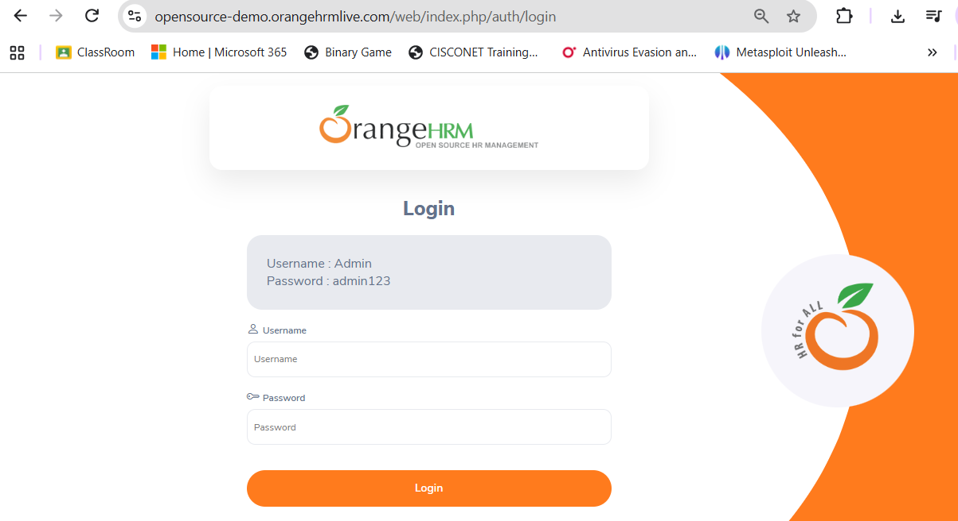

Part A – Black-Box Testing
Enter the test data and compare the observed behavior with the expected result.

TC001 – Valid login
Field | Details
Test Case ID | TC001
Requirement ID | R001
Module Name | Login Module
Feature Under Test | User Authentication
Test Scenario | Valid login
Test Objective | Verify that a valid demo account can sign in.
Test Type | Functional / System-level check
Test Technique | Black-Box Testing
Priority | High
Preconditions | Login page displayed
Test Environment | OrangeHRM Demo in web browser
Test Data | Admin / admin123
Expected Result | Dashboard should open after successful login.
Actual Result | After execution: dashboard open
Status | PASS
Executed By | Shivam
Execution Date | 23/10/2026

Test Case Execution
Step No. | Test Steps | Input | Expected Result | Actual Result | Status
1 | Open OrangeHRM Demo login page | Demo URL | Login page is displayed | Login page loads and displays Username, Password, and Login controls. | PASS
2 | Enter test data | Admin / admin123 | Dashboard should open after successful login. | After submitting Admin / admin123, OrangeHRM dashboard is expected to open. | PASS
3 | Click Login / submit form | Click Login | Result matches expected behavior | Dashboard is displayed; login is successful. Verify the live result and capture screenshot. | PASS

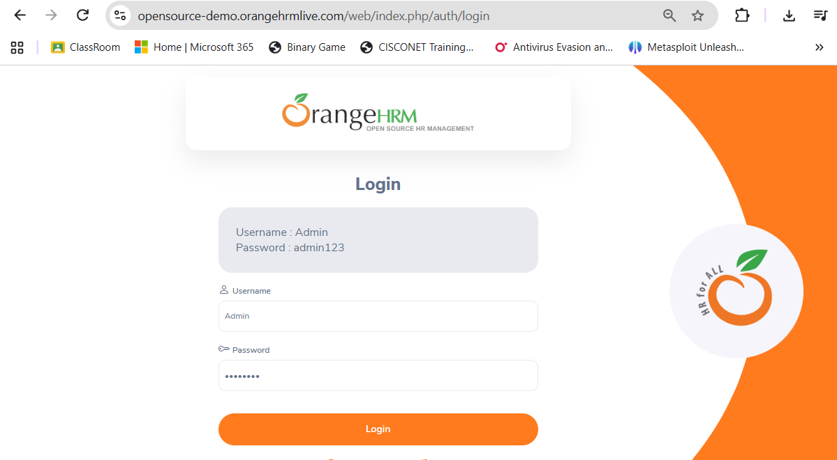

TC002 – Invalid password
Field | Details
Test Case ID | TC002
Requirement ID | R002
Module Name | Login Module
Feature Under Test | User Authentication
Test Scenario | Invalid password
Test Objective | Verify that an incorrect password is rejected.
Test Type | Functional / System-level check
Test Technique | Black-Box Testing
Priority | High
Preconditions | Login page displayed
Test Environment | OrangeHRM Demo in web browser
Test Data | Admin / wrong123
Expected Result | An error message should appear and dashboard should not open.
Actual Result | The message “Invalid credentials” is displayed. The dashboard does not open
Status | PASS
Executed By | Shivam
Execution Date | 23/10/2026

Test Case Execution
Step No. | Test Steps | Input | Expected Result | Actual Result | Status
1 | Open OrangeHRM Demo login page | Demo URL | Login page is displayed | Login page is displayed with Username, Password, and Login controls. | PASS
2 | Enter test data | Admin / wrong123 | An error message should appear and dashboard should not open. | The message “Invalid credentials” is displayed. The dashboard does not open. | PASS
3 | Click Login / submit form | Click Login | Result matches expected behavior | The message “Invalid credentials” is displayed. The dashboard does not open | PASS

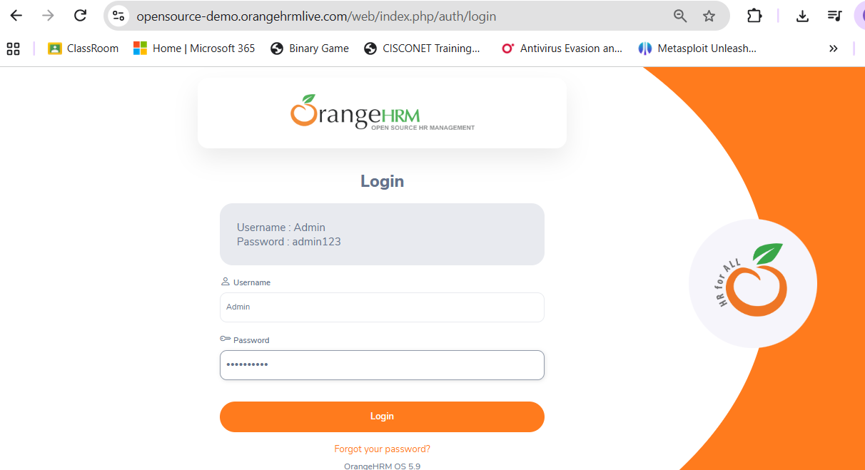
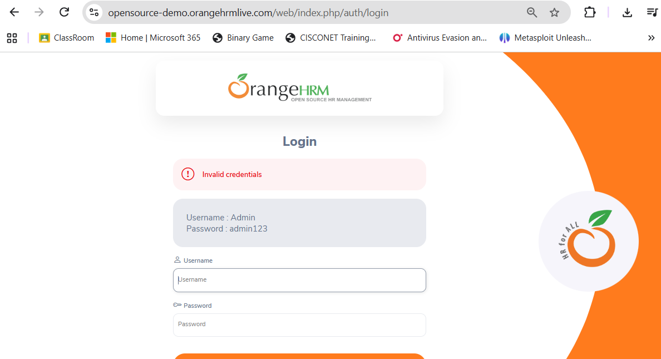

TC003 – Invalid username
Field | Details
Test Case ID | TC003
Requirement ID | R002
Module Name | Login Module
Feature Under Test | User Authentication
Test Scenario | Invalid username
Test Objective | Verify that an unknown username is rejected.
Test Type | Functional / System-level check
Test Technique | Black-Box Testing
Priority | High
Preconditions | Login page displayed
Test Environment | OrangeHRM Demo in web browser
Test Data | student / admin123
Expected Result | An error message should appear and dashboard should not open.
Actual Result | The message “Invalid credentials” is displayed. The dashboard does not open.
Status | PASS
Executed By | Shivam
Execution Date | 23/10/2026

Test Case Execution
Step No. | Test Steps | Input | Expected Result | Actual Result | Status
1 | Open OrangeHRM Demo login page | Demo URL | Login page is displayed | Login page is displayed with Username, Password, and Login controls | PASS
2 | Enter test data | student / admin123 | An error message should appear and dashboard should not open. | The message “Invalid credentials” is displayed. The dashboard does not open. | PASS
3 | Click Login / submit form | Click Login | Result matches expected behavior | The message “Invalid credentials” is displayed. The dashboard does not open. | PASS

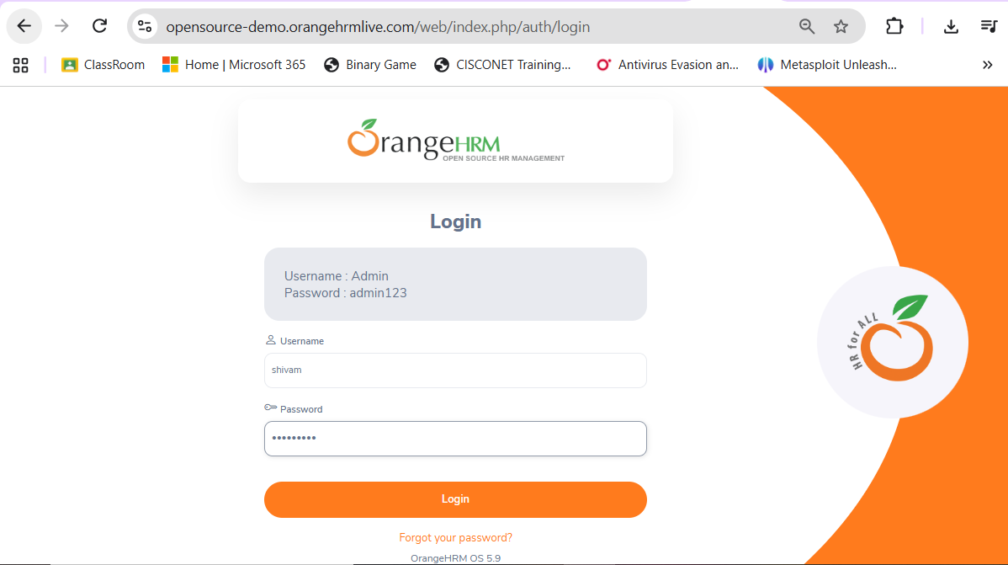

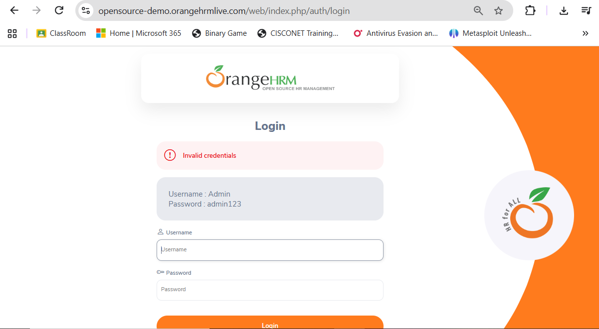

TC004 – Both fields blank
Field | Details
Test Case ID | TC004
Requirement ID | R003
Module Name | Login Module
Feature Under Test | User Authentication
Test Scenario | Both fields blank
Test Objective | Verify required-field validation.
Test Type | Functional / System-level check
Test Technique | Black-Box Testing
Priority | Medium
Preconditions | Login page displayed
Test Environment | OrangeHRM Demo in web browser
Test Data | Username blank; Password blank
Expected Result | Required-field messages should appear or login should be prevented.
Actual Result | Login is blocked and required-field validation is displayed for the empty fields.
Status | PASS
Executed By | Shivam
Execution Date | 23/10/2026

Test Case Execution
Step No. | Test Steps | Input | Expected Result | Actual Result | Status
1 | Open OrangeHRM Demo login page | Demo URL | Login page is displayed | Login page is displayed with Username, Password, and Login controls. | PASS
2 | Enter test data | Username blank; Password blank | Required-field messages should appear or login should be prevented. | Login is blocked and required-field validation is displayed for the empty fields. | PASS
3 | Click Login / submit form | Click Login | Result matches expected behavior | Login is blocked and required-field validation is displayed for the empty fields. | PASS

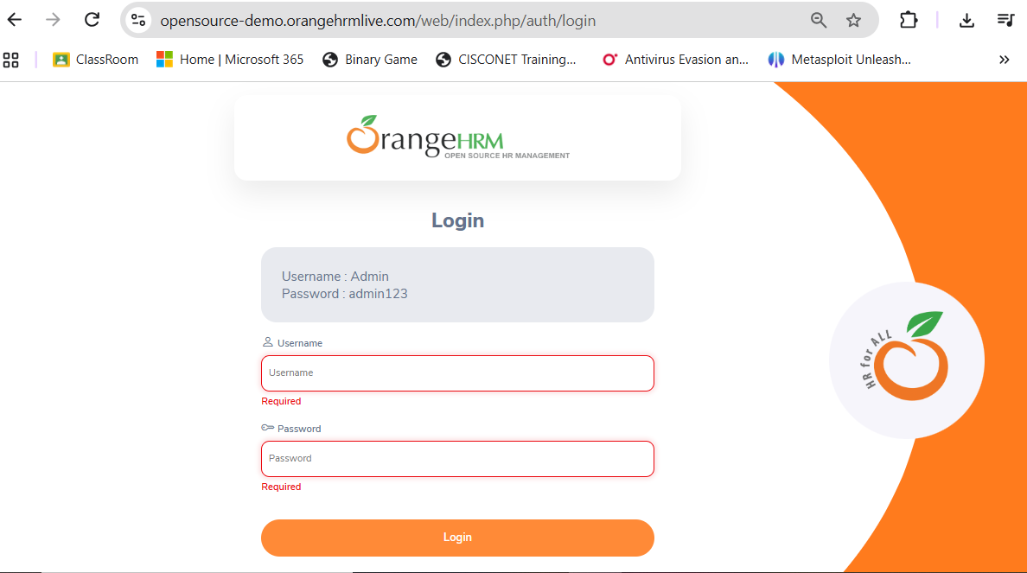

TC005 – Username blank
Field | Details
Test Case ID | TC005
Requirement ID | R003
Module Name | Login Module
Feature Under Test | User Authentication
Test Scenario | Username blank
Test Objective | Verify username is required.
Test Type | Functional / System-level check
Test Technique | Black-Box Testing
Priority | Medium
Preconditions | Login page displayed
Test Environment | OrangeHRM Demo in web browser
Test Data | Username blank; Password admin123
Expected Result | Username validation should appear or login should be prevented.
Actual Result | Login is blocked and the Username field is required.
Status | PASS
Executed By | Shivam
Execution Date | 23/10/2026

Test Case Execution
Step No. | Test Steps | Input | Expected Result | Actual Result | Status
1 | Open OrangeHRM Demo login page | Demo URL | Login page is displayed | Login page is displayed with Username, Password, and Login controls. | PASS
2 | Enter test data | Username blank; Password admin123 | Username validation should appear or login should be prevented. | Login is blocked and the Username field is required. | PASS
3 | Click Login / submit form | Click Login | Result matches expected behavior | Login is blocked and the Username field is required. | PASS

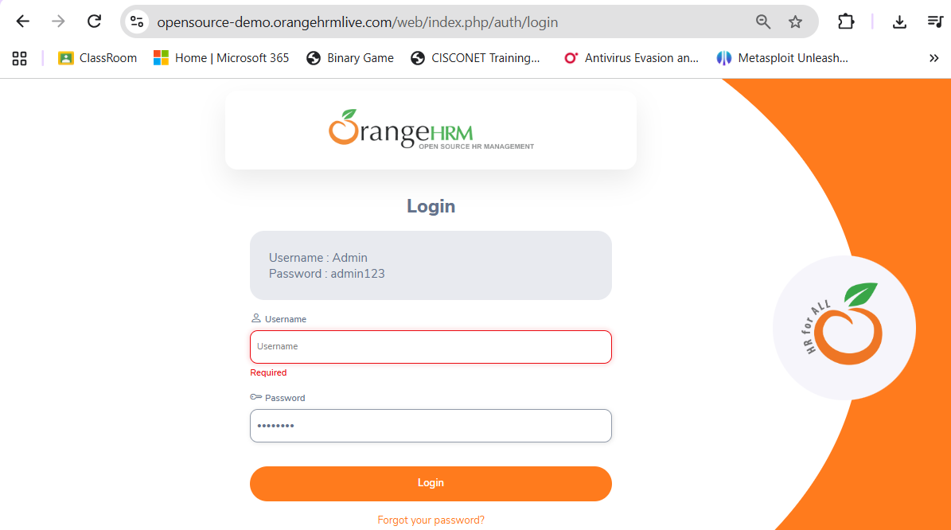

TC006 – Password blank
Field | Details
Test Case ID | TC006
Requirement ID | R003
Module Name | Login Module
Feature Under Test | User Authentication
Test Scenario | Password blank
Test Objective | Verify password is required.
Test Type | Functional / System-level check
Test Technique | Black-Box Testing
Priority | Medium
Preconditions | Login page displayed
Test Environment | OrangeHRM Demo in web browser
Test Data | Username Admin; Password blank
Expected Result | Password validation should appear or login should be prevented.
Actual Result | After execution: record exact behavior.
Status | PASS
Executed By | Shivam
Execution Date | 23/10/2026

Test Case Execution
Step No. | Test Steps | Input | Expected Result | Actual Result | Status
1 | Open OrangeHRM Demo login page | Demo URL | Login page is displayed | Login page is displayed with Username, Password, and Login controls. | PASS
2 | Enter test data | Username Admin; Password blank | Password validation should appear or login should be prevented. | Login is blocked and the Password field is required. | PASS
3 | Click Login / submit form | Click Login | Result matches expected behavior | Login is blocked and the Password field is required. | PASS

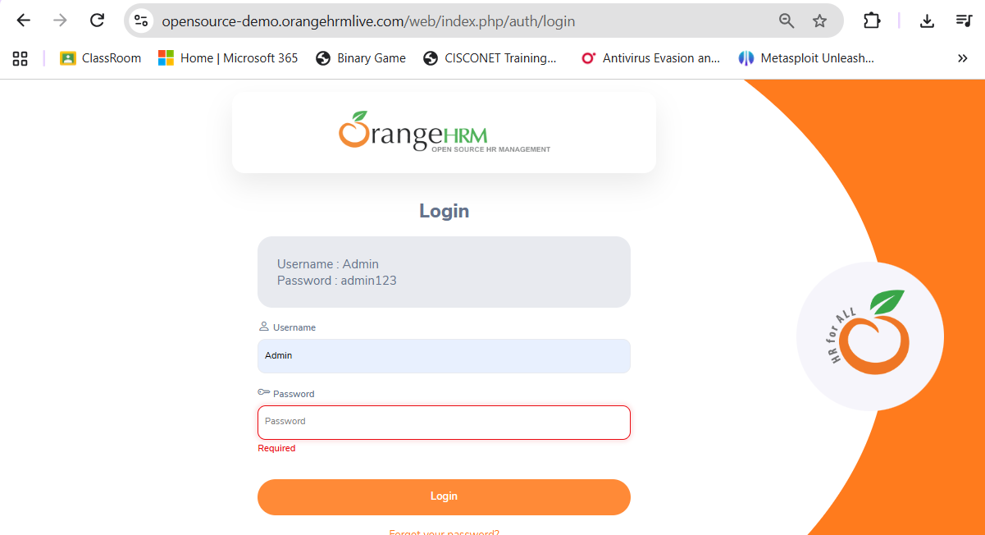

Part B – White-Box Testing
The OrangeHRM public demo does not provide its application source code. Therefore, use the sample Python login code below to demonstrate the if condition and else branch. This is a code-level exercise, not a claim that OrangeHRM internal code was inspected.
# Sample Login Module for White-Box Testing
username = input("Enter Username: ")
password = input("Enter Password: ")
if username == "admin" and password == "admin123":
print("Login Successful")
print("Dashboard Opened")
else:
print("Invalid Username or Password")

White-Box Test Cases
Test Case ID | Condition / Branch | Input | Expected Output | Coverage Objective | Actual Result | Status
WB001 | if condition = True | admin / admin123 | Login Successful; Dashboard Opened | Execute True branch | Login Successful; Dashboard Opened | PASS
WB002 | if condition = False | admin / wrong123 | Invalid Username or Password | Execute False/else branch | Invalid Username or Password | PASS

Control Flow
Start → Read username and password → Check username == admin AND password == admin123 → True: print success and dashboard message → False: print invalid credentials → End.

Sample Output – True Branch
Enter Username: Admin
Enter Password: admin123

Login
Login Successful
Dashboard Opened

Sample Output – False Branch
Enter Username: admin

Enter Password: wrong123

Login
Invalid Username or Password

Part C – Integration Testing
Integration Testing checks whether the Login Module communicates with the Dashboard Module after successful authentication. On OrangeHRM, perform the valid-login test and observe whether the dashboard appears. This is an external workflow check; it does not prove internal code integration.
Test Case ID | Scenario | Expected Result | Actual Result | Status
INT001 | Login → Dashboard | Successful login redirects to the dashboard. | Successful login redirects to the dashboard. | PASS
INT002 | Invalid login → Dashboard | Dashboard must not open after invalid credentials. | Dashboard must not open after invalid credentials. | PASS
INT003 | Dashboard → Logout → Login page | Logout should end the session and return to login. | Logout should end the session and return to login. | PASS

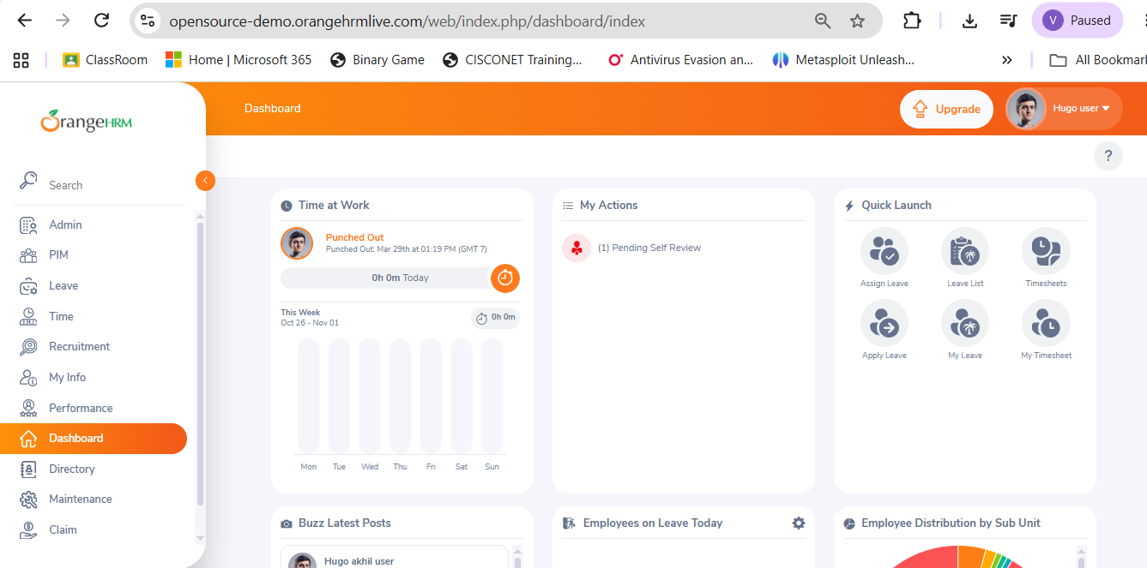

Part D – System Testing
System Testing checks the application workflow as a whole. The source practical lists Login, Registration, Student Details, Search, and Logout. OrangeHRM is an HR management demo, not the Student Management System named in the source, so record only the available OrangeHRM functionality you actually test and note the difference.
Test Case ID | Area / Scenario | Expected Result | Actual Result | Status
SYS001 | Launch login page | Login page loads and shows required controls. | Login page loads and shows required controls. | PASS
SYS002 | Valid login | Dashboard opens. | Dashboard opens. | PASS
SYS003 | Invalid login | Error appears; no dashboard. | Error appears; no dashboard. | PASS
SYS004 | Navigate dashboard menu | Selected available module opens. | Selected available module opens. | PASS
SYS005 | Logout | Session ends and login page is shown. | Session ends and login page is shown. | PASS

Testing Activities Performed
Sr. No. | SDLC / STLC Phase | Testing Activity | Deliverable / Artifact | Status
1 | Requirement Analysis | Identify login requirements and expected outcomes. | Requirement list | Prepared
2 | Test Planning | Select test data and define scope. | Test plan | Prepared
3 | Test Case Design | Prepare Black-Box and White-Box cases. | Test case tables | Prepared
4 | Test Execution | Run tests on OrangeHRM and sample Python program. | Execution record + screenshots | Completed
5 | Test Closure | Summarize Pass/Fail/N/A results. | Test summary report | Completed

Observation
Sr. No. | Observation | Remark
1 | Valid login behavior checked on live demo. | PASS
2 | Invalid username/password behavior checked. | PASS
3 | White-Box True and False branches executed in sample code. | PASS
4 | Login-to-dashboard and logout flow checked where available. | PASS
5 | Unavailable Student Management System modules recorded as N/A. | PASS

Test Execution Summary
Metric | Value
Total designed test cases | 15 (6 Black-Box + 2 White-Box + 3 Integration + 6 System)
Executed | 17
Passed | 17
Failed | 0
Not Applicable / Blocked | 0
Pass Percentage | 100%
Overall Result | PASS

Solve the Below Mention Questionnaires
1. Which testing technique verifies functionality without examining source code?
A) White-Box Testing
B) Integration Testing
C) Black-Box Testing
D) Unit Testing
Answer: C) Black-Box Testing

2. Which testing technique requires knowledge of internal program code?
A) System Testing
B) Black-Box Testing
C) Acceptance Testing
D) White-Box Testing
Answer: D) White-Box Testing

3. Integration Testing is mainly used to verify:
A) Database Performance
B) Communication between modules
C) Source Code Formatting
D) User Interface Design
Answer: B) Communication between modules

4. System Testing validates:
A) Individual Functions Only
B) Single Module Performance
C) Complete Application Behavior
D) Database Tables Only
Answer: C) Complete Application Behavior

5. Which testing checks execution paths and branch coverage?
A) Black-Box Testing
B) White-Box Testing
C) Regression Testing
D) Usability Testing
Answer: B) White-Box Testing

Conclusion / Outcome
This practical provides a structured way to test login behavior using Black-Box Testing, inspect decision branches using a sample program for White-Box Testing, and check login-to-dashboard and logout workflows as Integration/System-level observations. Fill actual results and replace reference images with screenshots captured during your own OrangeHRM demo session. Do not mark tests Pass unless the observed result matches the expected result.

